Testimony before
Health Coverage, Insurance, and Financial Services

An Act Regarding Women’s Health and Economic Security
LD 1613

Sam Zager, MD, M.Phil, FAAFP

February 13, 2020

Senator Sanborn, Representative Tepler, and distinguished members of the committee, my name is Dr. Sam Zager. I am a family physician and a member of Maine Providers Standing Up for Healthcare. I also have volunteered for years in a Title X funded clinic. I ask you to support LD 1613.

One of my patients--I’ll call her Emily--suffers from multiple physical and mental health conditions. Perhaps her biggest problem, though, is her abusive husband.

During one of our office visits, Emily nervously took a phone call and shrank in submission to the menacing voice bellowing from the other end. He gave her 15 minutes to be home; he said he’d time her. Emily’s husband manipulates and controls her in a number of ways, including forced, non-consensual sex. Emily does not want to bring a baby into an abusive home.

I urge support of LD 1613 for three reasons:

1. For Emily and tens of thousands of other Maine women, the statewide family planning network offers more than basic health care; it empowers them to have control over their bodies and lives.

2. Maine’s network also offers the dignity of a system that cares about, serves, and trusts all Mainers – including, or especially, those who struggle to access or feel seen in other health care settings.

3. Ensuring access to care fosters better outcomes at lower costs. In 2013, Wisconsin made family planning cuts that targeted Planned Parenthood. As a result, rural clinics closed, and STD rates began to climb. (see Figure 1)

The prevalence of one of their most important state-reportable diseases—gonorrhea—had actually been falling for eight consecutive years--until the 2013 cuts. Then the rate rapidly increased by 93%, beyond obliterating hard-fought gains.

When untreated, gonorrhea can lead to deadly infections of the tissues around the brain (meningitis), the heart (endocarditis), and the liver (hepatic abscesses), as well as excruciating pain, and infertility. Babies born to untreated mothers with it can go blind. We must not lose control of gonorrhea.

As awful as these complications can be, it’s fairly easy and inexpensive to diagnose and cure—provided people have access to services. That’s what this bill would ensure.

For the good of all of us, vulnerable populations and everyone need access to the full range of family planning services, such as birth control, STD screening and treatment, and cancer screening.

If LD 1613 doesn’t pass, we can expect reduced access to care. And after reduced access, we tend to see:
- more disease because prevention works(!) and
- higher costs because advanced problems are expensive(!).

But let us remember patients like Emily. For them, this bill is about much more than birth control, pregnancy tests, and health outcomes. For them, this bill is also about safety, security, and freedom.

I urge you to vote Ought to Pass on LD 1613. Thank you.

---------------------------------------------------------------------------------
Figure 1. State of Wisconsin – Gonorrhea Cases
(adapted from Kaiser Family Foundation graphic)
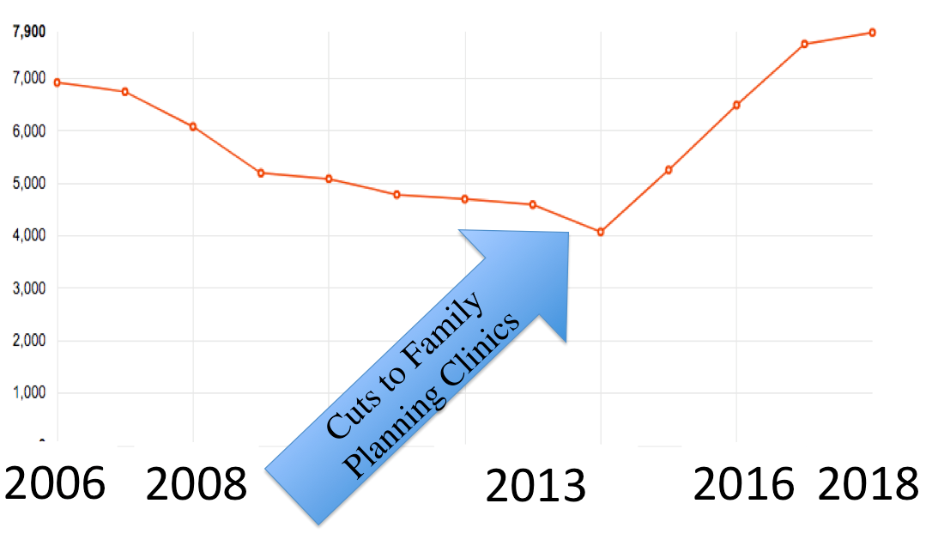
https://www.kff.org/other/state-indicator/gonorrhea-cases/?activeTab=graph&currentTimeframe=0&startTimeframe=12&selectedRows=%7B%22states%22:%7B%22wisconsin%22:%7B%7D%7D%7D&sortModel=%7B%22colId%22:%22Location%22,%22sort%22:%22asc%22%7D

This worsened rate far outpaced the nationwide increase, in a state that traditionally had lower-than-average STD problems. https://www.kff.org/other/state-indicator/gonorrhea-cases/
From 2014-2019, the prevalence of gonorrhea in Maine increased a jaw-dropping 270%. Maine Center for Disease Control Infectious Disease Program Quarterly Case Count Q1-3, 2019. https://www.maine.gov/dhhs/mecdc/infectious-disease/epi/publications/#surveillance

